Note: Pupils measuring their own BMI is optional only and not required to complete this project. If pupils are allowed to measure their own BMI please be aware how sensitive they could be about this.
The project actually highlights how BMI is sometimes not very good at identifying obesity (some athletes come out as being obese).
Also there are differences with age which do not get addressed, see graph
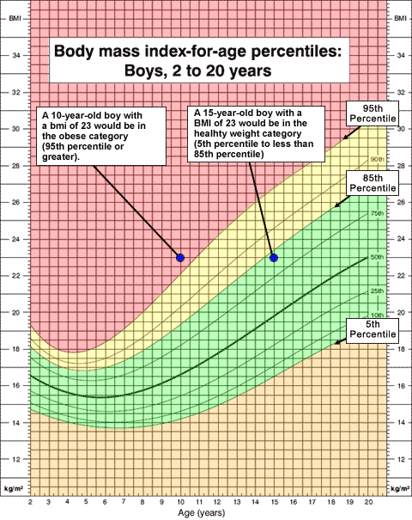
Body Mass Index.

The body mass index (BMI) is a statistical measurement which compares a person's weight and height. It is the most widely used method of identifying obesity problems within a population.
Below is how it is calculated and a table showing what every BMI value means;

Body Mass Index = Weight in kilograms
(Height in metres) ²

If you'd like to calculate your BMI yourself, follow these three steps.
- Work out your height in metres and multiply the figure by itself
- Measure your weight in kilograms
- Divide the weight by the height squared
For example, you might be 1.6m tall and weigh 50 kg.
The calculation would then be: 1.6 x 1.6 = 2.56.
BMI would be 50 divided by 2.56 = 19.5
Category | BMI range - kg/m²
Underweight | Less than 18·5
Normal | From 18·5 to 25
Overweight | From 25 to 30
Obese | Over 30

Body Mass Index Graph

Height (m)

2.00

1.90

1.80

1.70

1.60

1.50

1.40

1.30

Over weight

x
x
x
normal

x
Underweight

x
Obese

x

x
x

x

x

x
x
x

30 40 50 60 70 80 90 100 110 120
Weight in kg

This Body Mass Index graph shows the relationship between weight and height for the categories underweight, normal, overweight and obese.

Use the Body Mass Index Graph to answer these

If a student is 1.70m tall what weight could they be if they were ‘normal category’ for Body Mass Index?

You are told that some one is 70kg and in the ‘Over weight’ category what could their height be?

